Name Cherish Matson Date March 1, 2016 Period 2 BioTechnology: Web Quest

Part 1 - Manipulating Genes
Go to http://www.dnai.org/b/index.html

Read the introduction. What were some questions scientists asked in the 1970’s regarding the genes in DNA?

- Questions

Could there be some kind of molecular editing system?
What tools could be devised to work with genes?
Could scientists then create tailored DNA molecules?

Click on Revolution
Summarize the problem
- Summary of problem

Scientists did not know how to manipulate DNA in living things and whether or not it is dangerous.

Click on Pieces of the Puzzle (top menu bar)
Learn about each piece of the puzzle by clicking on it. Read the text and view the animations. Summarize what you have learned. You do not have to go in the order listed below.

- Restriction Enzymes – Restriction enzymes break apart bonds in the gene and leaves behind “sticky ends” that allows other molecules to connect to each other with the same sticky ends.

- DNA ligation - Ligase is considered the glue of gene mutation. It binds the genes together

- The First Recombinant DNA – Recombinant DNA is DNA that has been custom-made by combining different DNAs.

- DNA Transformation - DNA transformation is the isolated plasmid that the scientists wanted in order to make the gene or molecule they wanted.
Click on Techniques (bottom of page) Click on Cutting & Pasting (top of page)

Click on the Cutting & Pasting DNA button. Read the text and view the video.

- Make 3 sketches; a) Before DNA is cut b) After it is cut, and c) after it is pasted together. (Include nitrogen bases and which type of enzyme is used at each stage.)

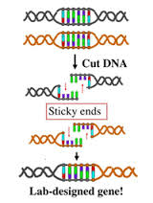
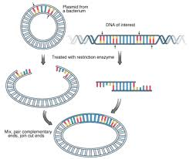
a) 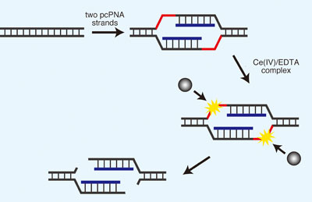 b) c)

Click on Recombining DNA. Read the text and view the video

7. What is a plasmid? A plasmid is a small DNA molecule within a cell that is physically separated from a chromosomal DNA.
What organisms have plasmids?
Bacteria, archaea, and eukaryotic organisms.

- Summarize the technique developed in the 1970’s in which a DNA fragment is added to a plasmid.

After researches implanted a DNA fragment into plasmid, the DNA created a new gene.

- Check out the interviews with the scientists that made these discoveries.

Done.

- If you are interested continue with the other techniques involved in manipulating DNA.

Part 3 – DNA Fingerprinting (an application of biotechnology)
Go to http://www.pbs.org/wgbh/nova/sheppard/analyze.html
In this section you will solve a “crime” by doing a “DNA fingerprint” found at the crime scene
and comparing it to the “DNA fingerprints” of several suspects. By comparing the DNA from
the crime scene with the suspects’ DNA you will find the “criminal”.
Read the introduction then proceed through parts 1, 2, & 3. Do the simulated procedure.
Which sister committed the crime? ________Honey_________.

Part 4 Applications
Go to http://www.dnai.org/d/index.html
You have already investigated one application of biotechnology in the above “fingerprinting”
activity. In this section other applications of the technology are explained. Choose between the
Genes & Medicine or the Human Origins modules and explore it. Pick an area of interest for you
in either module and write a short paragraph about it. What did you learn?

Humans have been around for thousands of years and we are the only humanoids left. Up until the 1900s many researchers believed that humans were related and linked to apes. Our bones and structures are much similar to those of apes and other primates who walk upright. Human DNA contains much information that can link us to passed ancestors and determine what life was like way back when. Now in this day and age, there is much genetic variation that distinguishes humans from other animals and even from each other.

