Cell Comparison

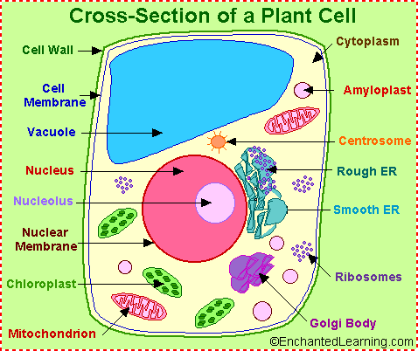
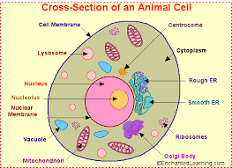
The animal and plant cells contain many of the same organelles. Animal and plant cells both contain a Nucleus, Cell Membrane, Lysosomes, Cytoplasm, Endoplasmic Reticulum, Mitochondria, Ribosomes, Golgi apparatus, and the Vacuole.

However, the animal and plant cells contrast in many ways. For example, the Vacuole in the animal cell comes smaller and in bounteous quantities. The plant cell also has a cell wall and chloroplasts. Both the animal and plant cells are microscopic, but the plant cell is larger and rectangular compared to the small round animal cells.

