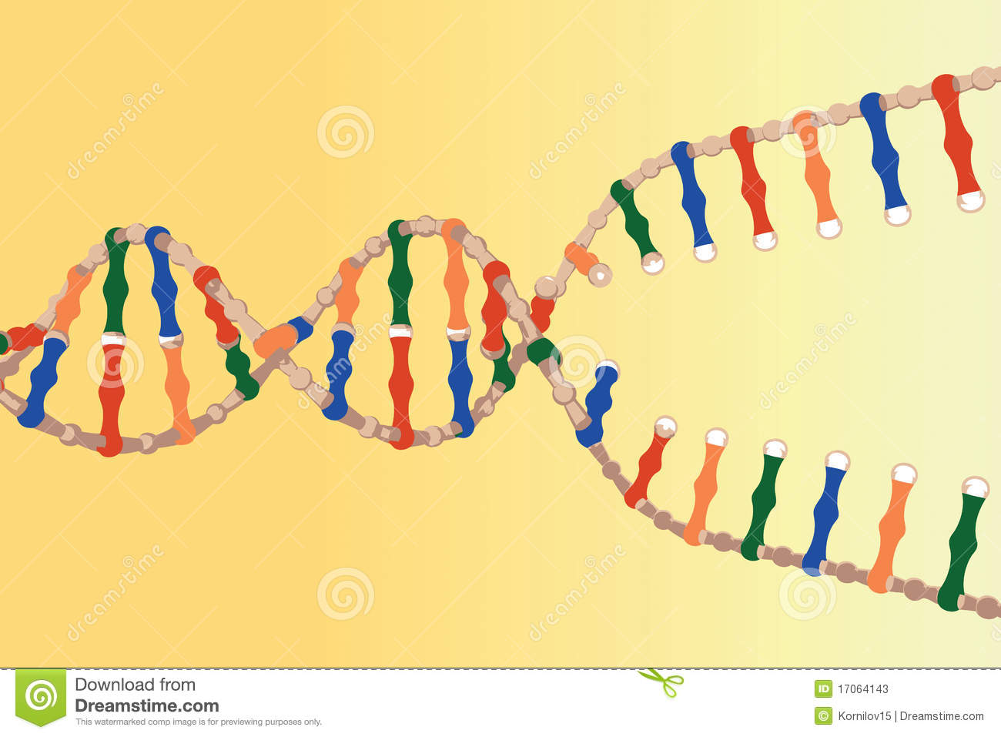

An enzyme breaks the hydrogen bonds

holding the nitrogenous bases together

unzipping the DNA

1.

2.

3.

4.

**DNA Replication Steps: words on left side and pic on right**

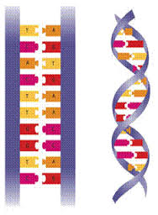

Nucleotides floating free in the surrounding environment attach to form base pairs by hydrogen bonding

2 identical molecules of DNA each molecule has 1 original stand and 1 newly created strand

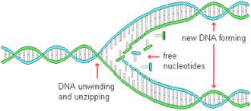

The bases hydrogen bond until the entire stand has been replicated

