Text Comparison Matrix
Concept/subject: Complex Inheritance

Type | Description | Example
Incomplete Dominance | Incomplete dominance is when the __phenotype__ of a heterozygous individual is an ___intermediate___ between those of the 2 homozygotes. | 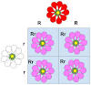
Co-dominance | Codominance is when the phenotypes of both __homozygotes__ in a heterozygous individual are expressed equally. | 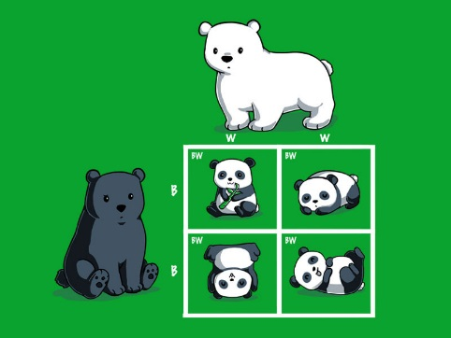
Multiple Alleles | Multiple alleles is an inheritance pattern where traits are controlled by more than __two__ alleles. | 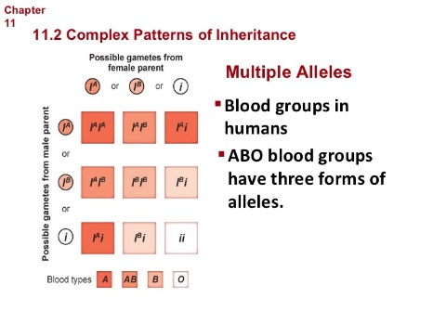
Sex-linked | characteristics determined by genes on sec chromosomes | 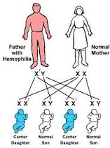
Polygenetic | Polygenic inheritance are traits controlled by more than one ___gene__. | 