Text Comparison Matrix
Concept/subject: Cell Cycle/Mitosis

Steps | Description | Picture
Interphase | Interphase is the beginning stage of mitosis, in which the chromatin remains intact. This is the original form of the chromatin. | 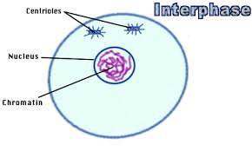
Prophase | Prophase is the second stage in which the cell enters during the cell cycle. The chromatin turn into the X phase and create chromosomes. | 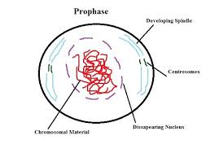
Metaphase | Metaphase begins when the chromosome is lined up in the middle of the cell and fibers attach to the chromosomes. | 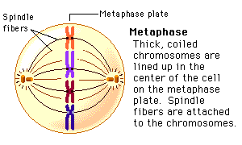
Anaphase | Anaphase is the fourth stage of cell division when the chromosomes are pulled apart and become V shaped chromatids. | 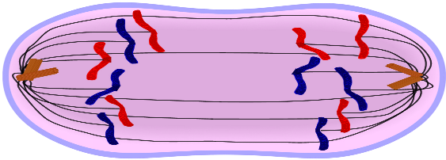
Telophase | Telophase is the final stage of cell division where the nuclear envelope begins to develop around the cell | 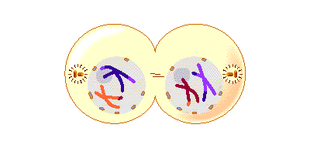
Cytokinesis | Cytokinesis is the stage where the cell has completely divided into two sister cells | 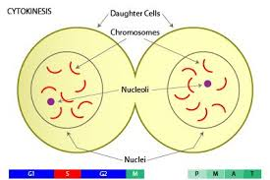
Summary: (discuss the importance of the cell cycle)

