Text Comparison Matrix
Concept/subject: Mutations

Type of Mutation | Explanation | Possible Results | Picture
Point | Point is the change of one single base pair. | The wrong amino acid can make the wrong protein. | 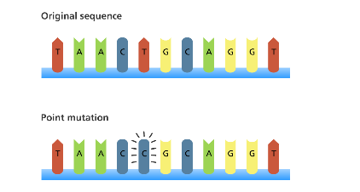
Frameshift | Single base is added or deleted from DNA sequence which causes shift in reading of codons. | All amino acids will be wrong. | 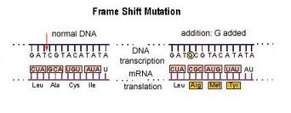
Deletion | The deletion of one amino acid | Create the wrong change of protein | 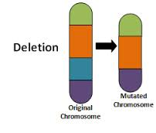
Insertion | The insertion of one amino acid | Create the wrong change of protein | 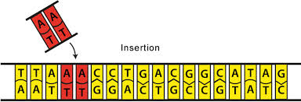
Inversion | Nucleotide rotates 180 | Offspring dies or sterile | 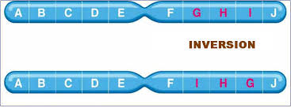
Translocation | Moved to new location | Offspring dies or sterile | 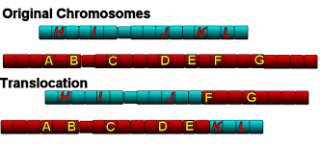
Summary: (discuss similarities and differences)

